ELECTRIC POWER DISTRIBUTION SYSTEMS

František Křižík, Thomas Alva Edison & Jára Cimrman

Abstract: The abstract of paper uses style Times New Roman 10 pt (Computer Modern) and should not be longer than 100 words. Papers will be reviewed by publishers and, when appropriate, returned to authors for corrections or additions. Papers in PDF and source formats (.docx, .tex, …, but not .doc) should be sent to e-mail address am2021@tul.cz till 5th April 2021. The name of the first author will identify the file, i.e. “Krizik_F.pdf”.

Introduction
The paper must be written in English. It should contain and be structured in the following way: introduction (problem statements, application area, research course), problem description, results, conclusion and references. Before authors is 1 empty line of 12 pt size. Before abstract is 1 empty line of 10 pt size.

Information
Use DIN A4 format. A single column layout is used. The paper is restricted to four A4 pages. The margin settings are on the first page is equal to 2.5 cm on the left, right and bottom of the page and 5 cm on the top of the page. The margin settings on the other pages are equal to 2.5 cm on the all sides of the page. The main body of the text is in Times New Roman (Computer Modern) 12 pt, justified. The first line of paragraph must be indented by 1.25 cm. Please, do not number pages of document. Each paragraph should have a top margin of 6 pt.

Titles And Subtitles
For titles of chapters use style Bold 14 pt (style = Title 1). Subtitles of chapters must be in style Bold 12 pt (style = Title 2). Before respectively after each title or subtitle should be margin of 18 pt respectively 12 pt.

Graphic Material
Figures, i.e. illustrations and pictures should be close to where they are referenced in the text. You should put a picture to the table with two lines, the first line should be used for a picture and the second line should be used for caption of the picture (Figure 1). The table should be without border. Color pictures are allowed.

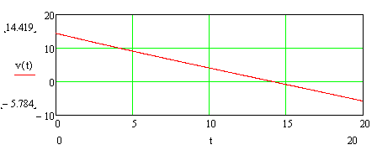
Figure 1: Title of figure uses style Times New Roman Italic 12 pt, put the “Figure x:” part of the caption in bold type.
If you want to place two or more pictures side-by-side across the width of the page, putting them into a table with the appropriate number of columns allows you to place their captions beneath them correctly (Figure 2).
Pictures in the table should be centred horizontally and vertically. Figures have to be made in high quality, which is suitable for reproduction and print (in order to achieve good quality reproduction it is recommended that pictures be scanned in at 300 dpi). Please insert picture with Insert command. Generally, please, make sure that all the objects are actually embedded in your file and not just linked to other files on your hard disk.

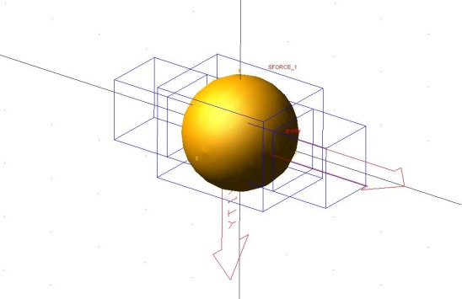 | 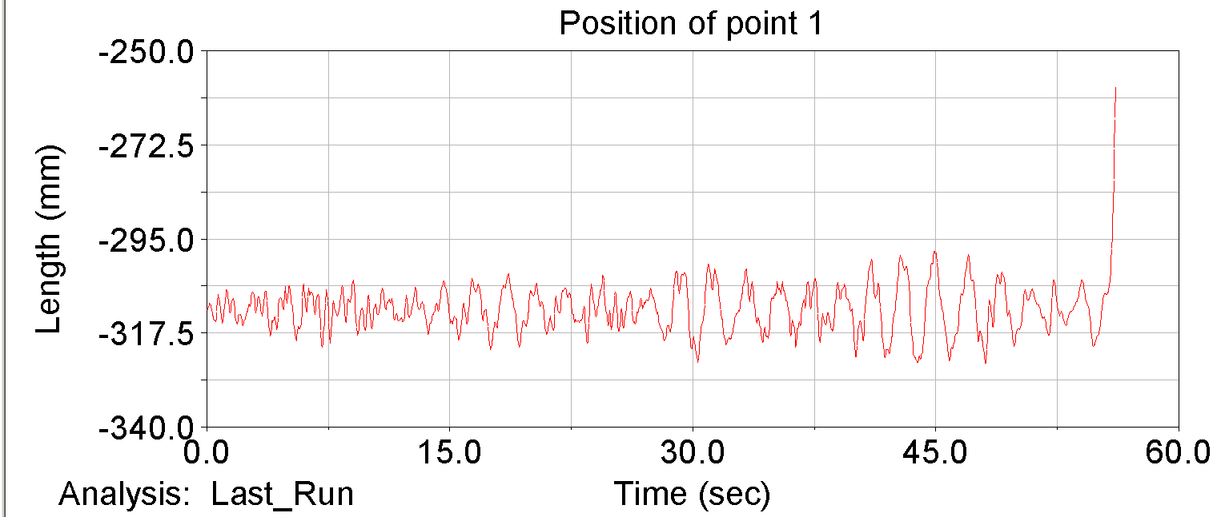
Figure 2: Times New Roman Italic 12 pt, put the “Figure x:” part of the caption in bold type. | Figure 3: Times New Roman Italic 12 pt, put the “Figure x:” part of the caption in bold type.
Equations should be centred and numbered consequently, from (1). For equations placing, please, use two tabulators. The first tabulator (for equation) is place in the centre of page with centre alignment. The second tabulator (for equations number) is placed id the right side of page with right alignment.
(1)
Tables (like figures) should be placed in the text close to where they are first referred to. Treat them like figures but place the caption above the table as shown for Table 1. Use first no bordered row for table caption.

Table 1: Styles in use in the preparation of this document
Style name | Typeface | Size | Alignment | Line spacing
Paper title | Times New Roman Bold | 16 pt | Centred | Single
Chapter title | Times New Roman Bold | 14 pt | Justified | Single
Author | Times New Roman Regular | 12 pt | Centred | Single
Abstract text | Times New Roman Regular | 10 pt | Justified | Single
Figure caption | Times New Roman Italic | 12 pt | Left | Single
Normal text | Times New Roman Regular | 12 pt | Justified | Single
References | Times New Roman Regular | 12 pt | Justified | Single
Table caption | Times New Roman Italic | 12 pt | Justified | Single

Referencing Convention
References should be indicated on the text by a sequence number in square brackets [1]. They should be numbered in the order in which they appear in the text. The reference should give the authors names – each followed by their initials, and then the title of the paper, the name of the journal or conference in which it was published, the volume number (if applicable) and the year of publication and page numbers. All references should be complete so that they can be found by anyone wishing to follow them up. ISBN/ISSN numbers should be provided where they have been allocated. For books the place of publication is also required. The conference list at the end of this specimen paper contains examples of the referencing of variety of journal, conference, book and other references the style of which should be followed in preparing your paper.

References

- Surname, N.; Surname, N.: Name of Book (in Italics), Publisher, ISBN, Place of Publication, (YYYY)
- Surname, N. & Surname, N.: Name of paper or Chapter, In Name of Book (in Italics), Publisher, ISBN, Place of Publication, (YYYY), pp. xxx-yyy
- Surname, N.; Surname, N., Surname, N.: Title of conference paper, Proceedings of xxx xxx, Surname, N. (Ed.), pp. xxx-yyy, ISBN, conference location, Month and Year, Publisher, City, (YYYY)
- Surname, N.: Name of paper, Name of Journal (in Italics), Vol. (YYYY) No., pp. xxx-yyy, ISSN
- Surname, N.; Surname N., Surname N.: Name of Paper, Available from http://www.exact-address-of-site Accessed: YYYY-MM-DD

Title Name Surname; Full title of the Institution; Street, ZIP-code City, Country, E-mail
For example: Doc. Ing. František Křižík, Ph.D.; Technical University of Stádlec, Department of Electrical Engineering; Táborská 2, 46117 Stádlec, Czech Republic, f.krizik@lampa.cz
all is written in Times New Roman 10 pt.

